Water Level Indicator

Description:
The Water Level Indicator is an electronic system used to monitor and indicate the level of water in a tank or reservoir. It helps users identify whether the water level is low, medium, or high and provides alerts to prevent overflow and dry running of pumps. This system ensures efficient water usage and reduces wastage by giving timely indications.

Block Diagram:
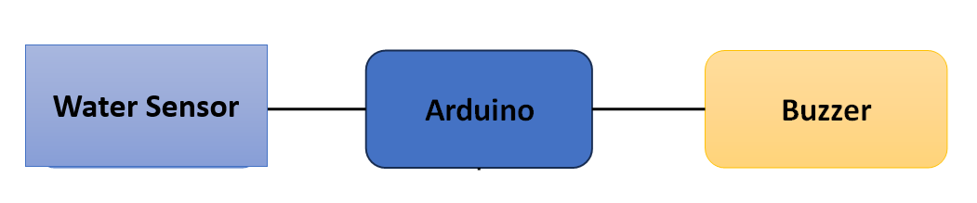

Pinout / Circuit Connection:
- Arduino Pin A0 → water sensor
- Arduino Pin 10 → Buzzer
- Arduino Pin 8,9 → LED
- Power supply: 5V (from Arduino USB or adapter)

Components Required:
- Arduino Uno / Nano
- Water sensor
- 2 x LED (with 220Ω resistor)
- 1 x Buzzer
- Jumper wires
- Breadboard

Working Principle:
The water level indicator works on the principle of water conductivity. Water acts as a conductor of electricity. When the water level rises and comes in contact with the sensor probes, an electrical signal is generated. This signal is detected by the microcontroller, which then activates LEDs or a buzzer to indicate the current water level.
Operation (Step-by-Step):
- Insert water sensor at the desired level inside the water tank.
- Upload the Arduino code to the board.
- Connect the components as per the pinout.
- Power ON the system.
- When water touches the probes → LED glows and buzzer beeps.
- When water level drops → alert stops automatically.

Arduino Code:
const int sensorPin = A0;

const int yellowLed = 8; // Half level
const int redLed = 9; // Full level
const int buzzer = 10;

void setup() {
pinMode(yellowLed, OUTPUT);
pinMode(redLed, OUTPUT);
pinMode(buzzer, OUTPUT);

Serial.begin(9600);
}

void loop() {
int waterLevel = analogRead(sensorPin);
Serial.println(waterLevel);

// EMPTY / LOW LEVEL
if (waterLevel <= 200) {
digitalWrite(yellowLed, LOW);
digitalWrite(redLed, LOW);
digitalWrite(buzzer, LOW);
}
// HALF LEVEL
else if (waterLevel > 200 && waterLevel <= 400) {
digitalWrite(yellowLed, HIGH);
digitalWrite(redLed, LOW);
digitalWrite(buzzer, LOW);
}
// FULL LEVEL
else { // 401 – 600
digitalWrite(yellowLed, LOW);
digitalWrite(redLed, HIGH);
digitalWrite(buzzer, HIGH);
}

delay(300);
}

Conclusion: (Predefined/self-written)
The Water Level Detector project teaches students how sensors can monitor water levels and trigger outputs like buzzers. Helps in saving water preventing overflow.

For Your References:
[1] Electronics Tutorials, “Water Level Detector Circuit,” Electronics-tutorials.ws, 2023. [Online]. Available: https://www.electronics-tutorials.ws/water-level-detector. [Accessed: 27-Aug-2025].
[2] Arduino, “Digital Read Function,” Arduino.cc. [Online]. Available: https://www.arduino.cc/reference/en/language/functions/digital-io/digitalread/. [Accessed: 27-Aug-2025].

